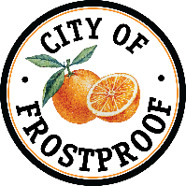

CITY OF FROSTPROOF
INVITATION TO BID (ITB)
MILLING AND RESURFACING PROJECT – WEST WALL STREET
The City of Frostproof, Florida, is requesting sealed bids from qualified contractors for the milling and resurfacing of West Wall Street, beginning at State Road 17 (SR-17) and ending at Oak Street, within the City of Frostproof.
There will be a non-mandatory pre-bid meeting on Friday, June 5th at 9 a.m.to walk through the project. Sealed bids will be received by the City of Frostproof until Thursday, June 18th at 3:00 p.m. local time at which time they will be publicly opened and read aloud at 111 West 1st Street, 2nd Floor, Frostproof, FL 33843.
Bid documents, specifications, and project map may be obtained from the City of Frostproof City Clerk: clerk@cityoffrostproof.com, 863-635-7854.

